PIP ONLINE DIRECTORY INSTRUCTIONS – the first time you login, go through these steps. After the first time, you will only need to login like a regular website.
HOW TO LOGIN:
Please make sure your family name / group is selected as the system will recognize your email.
1) Click here to log in: http://ptoffice.mjssoftware.com/account/MemberRegistrationByFlyer?H+rKrMfrpXdBUApuqPPFbpCutCBd/Ri7osYSQeTaDp3RfPixLrIB44EqxQn7aALy

The new login password is: imagine2015
2) Then proceed to create your login information with your name, email & password.
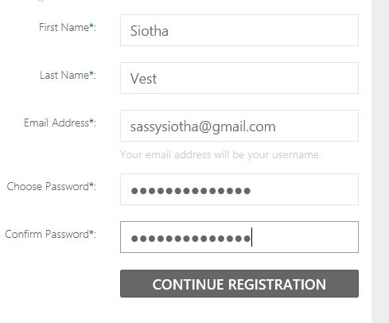
Click Continue registration.
3)The next screen matches your family information to whom you are. Please use the search function if your immediate information does not appear.
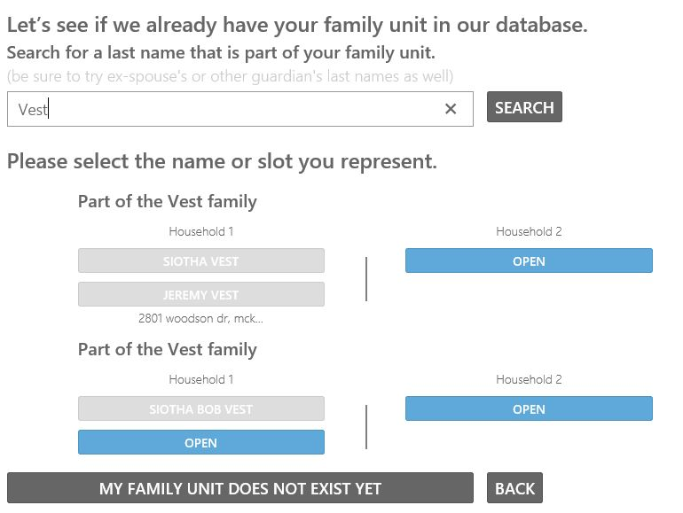
Click the blue button to which your profile will match. (if this is grayed - please use household 2, then send an email to siotha stating: Household 2, please Fix my listing)
If your household is not listed, click my family unit does not exist.
4) You may add as much or as little information as you like on the next screen. But by clicking the check box - the information is chosen to be public to PiP members only.
5) The next screen will ask for your membership. PAID MEMBERS: Click Continue!
Non-Paid Members may pay online with a $1 convenience fee.
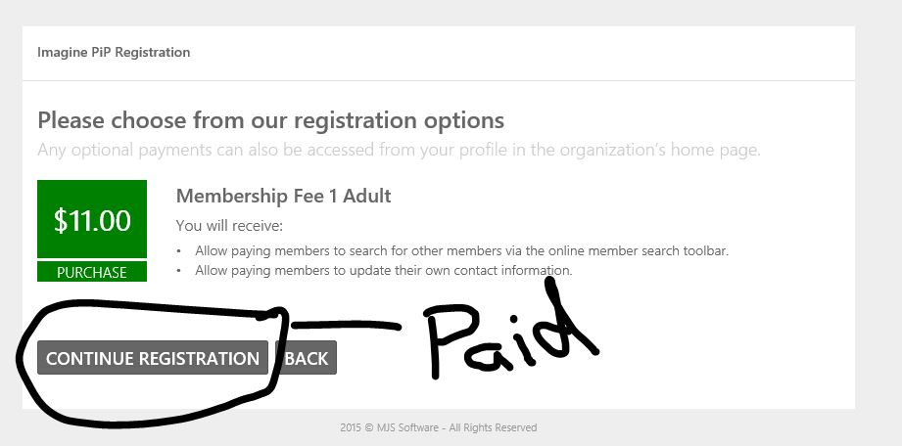
6) During this process, the PiP board minutes will appear, they are accessable by all paid members. If you choose to read them great, otherwise scroll down and click continue.
7) The final security check is a captua. Enter the Number and check the box I agree to terms & conditions. Then click continue to registration.
(note, if an error occurs, please wait 30 seconds, then close the browser window. *** This is a known error *** it is not a problem.
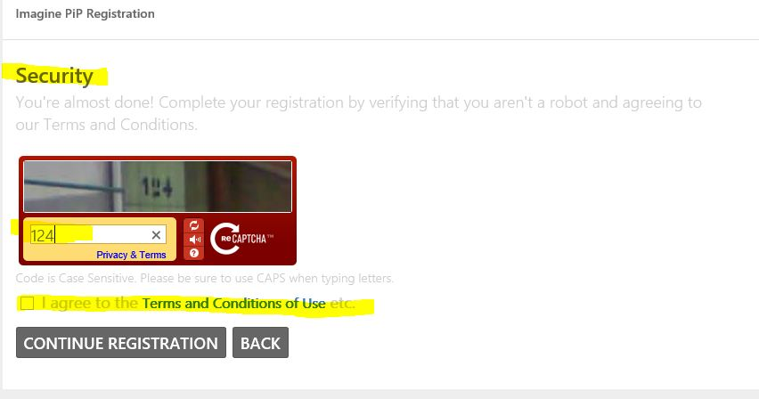
That it, you’re done.
Use the next page to access the directory.

8) Now - Login to your account to see the directory: http://ptoffice.mjssoftware.com/mywebsite/Imagine_PiP_TX
Click the remember me button, or you'll always have to enter the state & name of pip when you log in.
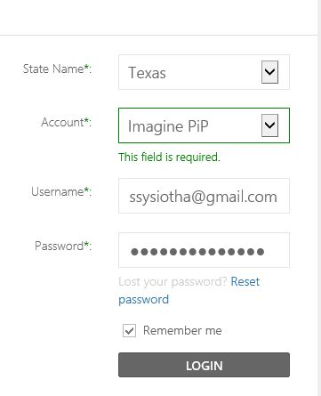

DIRECTORY ACCESS:
You will immediately see the directory search bar. Use this to find other parents in your children's class.
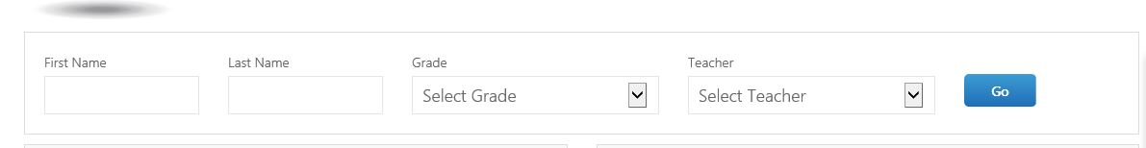

MEMBERHIP INFO: Then you can update and change your directory information at anytime, on your membership page.
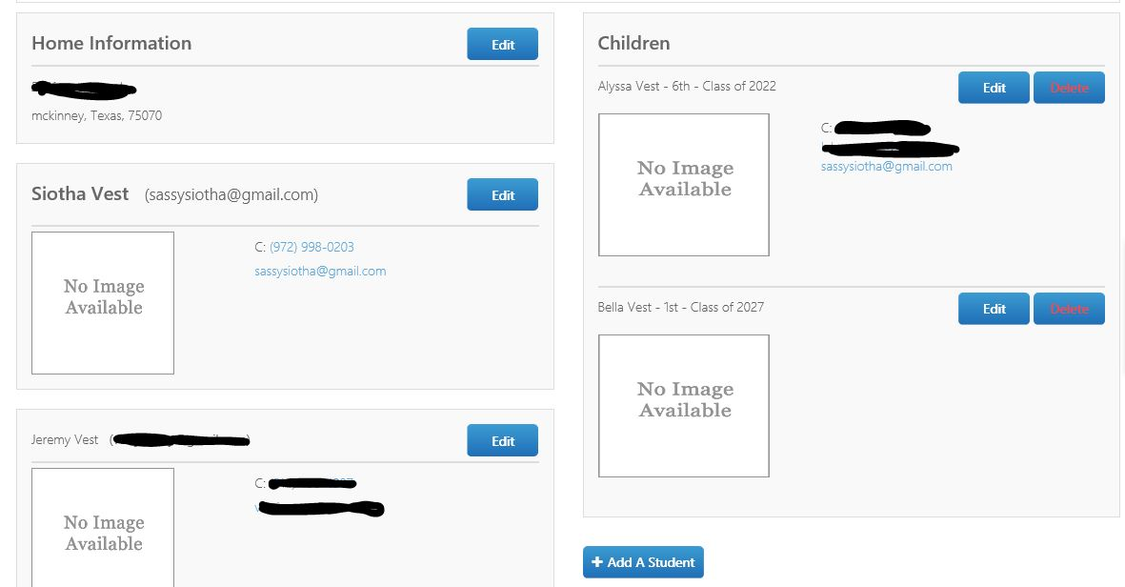
Thanks so much and we hope to see you ‘online’ soon

