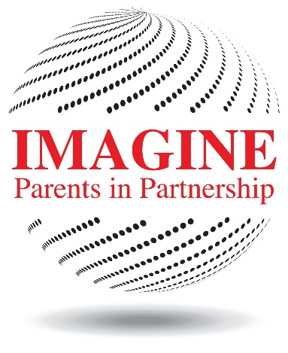
Welcome Back Dragon Parents!

We are excited to launch our new logo because symbols matter. We wanted to start this year off with a new logo to symbolize a fresh start for Parents in Partnership (PiP). The school we serve is very young and dynamic which means PiP must alter our course when necessary to fulfill our mission of bringing students, parents and teachers together as a community. To that end—the 2015-16 Imagine PiP Board pledges to demand accessibility, accountability and credibility from itself and any activity that we sponsor.

Our board has completely turned over from the 2014-15 board. This is very unusual for a non profit and it has created many challenges. We hope that you will remain patient with us while we stabilize the organization. Some special events may look different or may not happen this year. That doesn’t mean PiP cannot make them happen in the future. Please feel free to let us know if you feel strongly about an activity or event of PiP—but be prepared to help make it happen. We welcome your thoughts and opinions—but we also need your help. Many parents must volunteer and contribute for PiP to succeed.

Our primary responsibility is to build the IIANT community and we cannot do that without your confidence in how your resources are used. Going forward, anyone is free to look at our financial records at any time. Our board meetings are open-any member may attend because THIS IS YOUR ORGANIZATION. However membership will not be automatic. You must take the responsibility to join PiP this year—which you will have the opportunity to do at the upcoming back to school events. We hope that you do. Joining PiP gives you a voice in how we run our organization as well as benefits—more details to follow in the upcoming IIANT newsletter, back to school nights & online.

In the mean time we want your feedback, follow this link https://www.surveymonkey.com/r/NQCHGR5 to take a 2 minute survey so that we can gauge what parents want from PiP and what resources they are willing to contribute. Taking this survey will give you immediate input into PiP’s strategic decisions.

Finally we are very excited to announce that Mr. Menzies, the new Head of School will be our featured speaker at our kick off general meeting on August 27. You will have the opportunity for Q & A with him. We welcome you to the meeting to see what the board has been working on this summer as well as to have input on our future.

We are excited about 2015-16 and beyond for PiP. Please join us!

Claes Brameus
2015-16 Board President
Imagine.pip@gmail.com

Additional 2015-16 Board Members:
Cissy Oldner, President Elect
Amy Colandrea, Treasurer
Charles Gore, Programs
Ram Singh, Committees
Siotha Vest, Secretary
Open, Communications

